**1.2 Introduction of project**

This application is basically developed for the Customer purpose only because at one place customer get the all required data area wise. In our application Customer send the requirement to the respective engineer area wise. Then Customer gets the multiple quotations from the multiple vendors in respective area only.

This Application is developed for the Commercial business organisations to manage their engineers and customer’s data effectively and to improve their profit which will helps to increase the organisations business. It will not just to maintain engineers and customer’s details and their data but it also provides some features that helps to business organisations to increase communication with their customers using some facilities of this system such as Email and SMS facilities. A engineers gives us on time delivery and minimum time for making your dream home .

It also provides the customization facility to admin so that admin can customize this system as per his/her organizational needs. Business organizations can manage their inventory management and support tasks through this system. They can also manage their Engineer list, Customer List, Various packages and offers; Advertisement, Banner and Slider, Area and category, Add new product in list contact us enquiry messages.

Business organizations can also generate reports in various formats and these reports help business organizations for various types of analysis. They can use these reports in decision making processes and also for customer satisfaction by analysing their needs and problems.

**1.3 Existing system & need of the system**

In Dream Home system user want the best design for their home ,buildings ,hospitals ,hotels ,restaurant ,classroom ,study room ,halls ,bathrooms , and most important bedrooms and kitchens etc. but they do not get the proper design which fulfill the requirement of the customer. But in our system user get the best design for their home.

Firstly when user visit on our site at that time user get overall information about our system and if user like some design for their construction he want to register on our site. After the registration on that site the user get the username and password using that username and password user get login onto our system.

After the login user get the suitable design for their home and other place. If they do not like any design or any queries about the designs user can send the message to the system where our system interact with the user . Also there is a admin who control the user registration. If user want to personally communicate through the system on contact screen there is contact detail was provided also there is address of our company was provided .If user have small queries then he want to fill the contact form through that contact form admin get detail about problem .

If user can login successful at that time customer get services as per the section which are bedroom ,kitchen ,study room ,class room ,hotel ,balcony ,bathroom ,hospitals ,hall ,dining room .If user like some designs then user want to select those design which are they want. If he could not like then send graphic detail to admin and get better matching designs.

**This system provides the following facilities that other systems not provide these facilities and hence this system is needed for following facilities:**

1. To reduce the workload for maintaining Engineer and the customer data manually, this system will helps to manage Engineer and the Customer details and their complete data.
2. Using this system Admin can manage their Engineer list, Customer List, Various packages, Advertisement, Banner and Slider, Area and category, contact us enquiry messages User can also manage the quotes and invoices using this system.
3. This system provides the facility to the users so admin can customize the system as per their needs such as add area and the category etc.
4. This system provides mail manager facility by using this facility Admin can communicate with the Engineer within the particular area as well as with the customers.
5. Users can also manage their documents and tasks.
6. User can send the SMS to customers for promoting their products or SMS as a response to customer’s complaints or requests.

**1.4 Limitations of Existing system**

The limitations of existing system are as follows:

1. In manual system User can’t get the multiple quotations at a one time from various engineers in respective area only.
2. In manual system we can’t create the dynamic website.
3. In manual system there is no any adding banner and slider customizable facility.
4. In manual system there is no any advertising management system.
5. We can’t create the package in the manual system regarding showing the advertisement on the Dream-Home website.
6. Improve rank facility is not available in the existing system.
7. There are many organizations that use Ecom applications but it has a many restrictions as compare to web based Customizable Ecom applications.
8. There are many Ecom systems/shops available in market but many of them not provide the facility of Mailing and SMS notifier and also not provided delivery at your door.
9. Many Ecom systems/shops just provide the facility of managing customer details documentary (shop only).
10. Many Ecom applications don’t provide the facility of document management.
11. Many of the applications don’t provide the facilities to manage inventory related tasks.
12. The existing applications don’t provide the facility of application customization. Many of the existing Ecom systems don’t provide the functionality like using this system Admin can manage their Engineer list, Customer List, Various packages, Advertisement, Banner and Slider, Area and category, contact us enquiry messages User can also manage the quotes and invoices using this system.
13. **PROPOSED SYSTEM**

This system is to provide the best solutions to the organizations to manage all their data about customers, Vendors, Customization facility, Using this system Admin can manage their Engineer list, Customer List, Various packages, Advertisement, Banner and Slider, Area and category, contact us enquiry messages, Improve rank Management, Make Dynamic website and all.. It provides the fully customized Ecom system.

**Problem Statements**

**Problem No 1:**

|  |  |
| --- | --- |
| The problem of | Maintains Customer and Engineer details and their data manually is tedious and crucial task. |
| Affects | Effects on Business Growth. |
| The impact of which is | Difficult to maintain data and is very time consuming. |
| A successful solution would | Provides a system to maintain data with Admin interface which must be attractive and easy to understand and use for non technical users.  Contact Management is provided to Admin to manage the contact details of customers. |

**Problem No 2:**

|  |  |
| --- | --- |
| The problem of | Much Customer Uses Ecom system but their data is distributed at various places so it is very tough to get required data and it takes a large time to get required data. |
| Affects | Effects on Business Growth. |
| The impact of which is | Difficult to find particular required data and is very time consuming. |
| A successful solution would | Provides a centralized database to maintain data with a user interface which must be attractive and easy to understandable. |

**Problem No 3:**

|  |  |
| --- | --- |
| The problem of | Much Customer Uses Ecom system but that are not customizable so they has to use the system only with available resources. |
| Affects | Effects on Business Growth. |
| The impact of which is | Difficult to use system. |
| A successful solution would | Provides a fully customizable system to Admin with a user interface which must be attractive and easy to understand and use for non technical users. |

**Problem No 4:**

|  |  |
| --- | --- |
| The problem of | Data access for limited period and limitation of places. |
| Affects | Effects on Business Growth. |
| The impact of which is | Admin can’t access data from different places when they want to access and it has a time period limit. |
| A successful solution would | Provides a web based system to maintain data with a user interface which must be attractive and easy to understand and use for non technical users so users can access the data from anywhere and data will be get available for 24/7. |

**Problem No 5:**

|  |  |
| --- | --- |
| The problem of | Communication Gap between Admin, Engineer and Customers. |
| Affects | Effects on Business Growth. |
| The impact of which is | Difficult to maintain communication with Admin, Engineer and Customers and it is very time consuming and it requires external resources i.e. external communication applications or other optional system for communication and it increases the cost. |
| A successful solution would | Provides a inbuilt email and SMS notifier system to communication with Admin, Engineer and Customers which must be attractive and easy to understand and use for non technical users. |

**Problem No 6:**

|  |  |
| --- | --- |
| The problem of | Creating various reports by analyzing the huge data manually is very time consuming and lengthier task. |
| Affects | Effects on Business Growth. |
| The impact of which is | Difficult to maintain data and create reports and is very time consuming. |
| A successful solution would | Provides a automatic and customizable reports to users on their needs. |

**Problem No 7:**

|  |  |
| --- | --- |
| The problem of | Many Ecom systems don’t provide the facility to Create a dynamic website and rank improvement facility. |
| Affects | Effects on Business Growth. |
| The impact of which is | Difficult to maintain data and create reports and is very time consuming. |
| A successful solution would | Provides a automatic and customizable reports to users on their needs. |

* 1. **Product Position Statement**

|  |  |
| --- | --- |
| For | User |
| Who | Business Organization |
| Dream Home | Is an web based application |
| That | Helps users to manage their Engineer and Customers data and provides more functionalities that helps to analyze customers and also for decision making such as campaign, leads, opportunities. |
| Unlike | Manual System or existing individual applications. |
| Our product | This product will help to business organizations to maintain Engineer and Customer and product details and also helps in decision making. |

* 1. **Product Overview**

This system is designed for business organisations to manage their Engineer and Customer Details, product details, their various tasks and to manage other information such as system Admin can manage their Engineer list, Customer List, Various packages, Advertisement, Banner and Slider, Area and category, contact us enquiry messages, Create dynamic website and improved rank management.

# Assumptions & Dependencies

1. To use this system user needs a internet connection with good speed.
2. It is assumed that users know his/her tasks in organisations.
3. Only Register Customer can access this system.
4. Only Register Engineer can access this system.
   1. **Objectives**

* By using this application Customer get multiple quotations in one click only.Multiple quotations at a one time from various engineer in respective area only.
* Using this application we create the dynamic website of the registered customers.
* Ecom provide the access to the admin to add banner and slider dynamically so it’s a customizable facility.
* In our application Customer send the requirement to the requirement area wise.
* Then Customer gets the multiple quotations from the multiple Engineers in respective area only.
* Dream Home provide advertising management.
* System provides the facility to the Admin Create package.
* Improve rank facility is available in our application.
* Our application is also provide the facility of Mailing and SMS notifier.
* Provide the facility of Report Management.
* Our application provides the facilities to manage inventory related tasks.
* Our application provides the facilities to how to search engineer according to our requireemnts.
* Dream Home applications provide the facility of application customization. Admin can manage their Engineer list, Customer List, Various packages, Advertisement, Banner and Slider, Area and category, contact us enquiry messages User can also manage the quotes and invoices using this system.
  1. **Functional Requirement**

The functional requirements of this system are as follows:

1. **Marketing and Sales:**

* **Enginee**r **and the Customer Management:** Admin can manage their all details.
* **Advertisement Management:** Admin can manage their all Ad details.
* **Contact Us Management:** System can manage their all customers contact details.
* **Product Category Management** System can manage all the details of the organizations with which the organization have some service contracts or tie-ups.
* **Report Management:** Organizations can manage all the details of their Vendor and the customer.
* **Package Management:** System can manage all Package related Data.
* **Improve Rank Management:** System can manage all their Rank details data.
* **Dynamic Website Management:** Admin can manage Dynamically created website data Customer wise.
  1. **Non-functional requirements**

# The non-functional requirements are as follows:

### Security:

* Each member is required to have an individual password
* Administrators have the option of increasing the level of password security their members must use.
* For maximum security, each member must protect their password.

1. **Reliability:**

* System will prompt the user if any incorrect input is made.
* To handle data consistency, DBMS software is used.
* User can easily work through the different menus and buttons.

1. **Maintainability:**

* Proper documentation is available for further upgradation and maintenance.
* User will be trained enough to handle the minor changes required.

1. **Availability:**

* The system shall be available all the time.

1. **Portability:**

* System is independent of hardware specification.
* It can run on any operating system
* System is independent of browser compatibility because web pages will be designed by JSP and Strut2.0.

1. **Performance:**

* The performance of our product is at its best if stored locally, as the response time will be much faster.
* If the product accessed via Internet, the performance is limited by the connection speed.
* The only foreseen limitation is that of web server response.

1. **User Friendly:**

* Our system is very easy to use and user friendly. Its GUI is very attractive and understandable to the common users.

## Stakeholder Summary:

|  |  |  |
| --- | --- | --- |
| **Name** | **Represents** | **Role** |
| SSP Technology | Owner of System | This is the organization that is owner of this system and has all rights about system and its sales rights. |
| Administrator | Admin of the System | The Administrator is a user of system who can create users, provides rolls to users, customize the system and can use all the functionalities provided by the system. |
| Vendor/User of System | User of System | The user can use various functionalities provided by this system. |

* 1. **Scope/Implementation**

In this System there are three main modules and some sub-modules which come under these main modules and that are as follows:

1. **Admin**

**a. List of Customers-**

In this module admin can see the list of the registered customer. Here are the rights to the admin to add, update, and delete the record of the customer.

**b. Advertisement-** This tab is completely useful to deal with the advertisement activities.

**1. Add Banner (on website Home page)-**

Here admin add the Dealer banner on Home page as per the package purchased by the . Dream Home Here Admin can show at least 6 Banner on the website Home page. Those who pay the more amounts to the admin that means the Bank Adminpurchase the high paid package his/her banner will be show on the website homepage.

**2. Add Slider-**

Here admin add the Dealer banner on Home page as per the package purchased by the Dealer. Here there is option on the Home page of the website to show the Dealer Banner

**3. Add Product Advertisement-**

Here admin add the Engineer banner on Home page of the Advertisement menu. The package purchased by the Dealer. Here there is option on the Home page of the of the Advertisement menu website to show the Engineer Banner. Here Admin can show Banner on the website Advertisement Menu on Home page. Those who pay the more amounts to the admin that means the Engineer who purchase the high paid package his/her banner will be show on the website homepage. Here the banner is showing by the product category wise only.

**c. Add New-** This option is very useful to create the package and the add area and the category.

**1. Create Package-**

Here the admin can create the package with the duration and the price. Once the package is created then it will be reflected in the customer panel for purchasing the package. Here admin can Create, Update, Delete the package.

**2. Add area and category-**

By using this tab the admin can add the area and the category dynamically. Then this area and the category will be reflected in the customer panel. Here admin can Add, Update and Delete the category.

**3. View area and category-**

Here the admin can see the area which is already added and the category.

**c. Vendor-**

**1. Engineer Registration-**

By using this panel tab the admin can do the registration of the new Vendor. Then the respective Vandor gets the username and the password through the registered email id. There is no any separate link to do the registration of the Engineer directly.

**2. View Engineer List-**

Here admin can see the list of the entire **Enginee**r those who already registered. Here admin have the rights to add delete and the update the list of the Vendor.

**3. Improve Rank-**

Here the admin can improve the rank of the Engineer Banner on the website through this panel on the basis of the package purchased by the Engineer. Here admin have the rights to see the list of the Vendor who already improve their rank.

**4. View Improved Rank-**

Here admin can see the list of the Engineer those who already improved the rank. Here admin can Delete, Update and Edit the record of the Engineer.

**5. Create Dynamic Website-**

By using this option admin can create the dynamic website of the Dream Home Dream Home Dream Home Dream Home Dream Home Dream Home Dream Home Dream Homes under the domain of the [www.dreamhome.com/xyz](http://www.dreamhome.com/xyz). Suppose here we create the dynamic domain like xyz. Here again the vendor must have to purchase the package to create the dynamic website.

**6. View Created Website-**

Here admin can view all the dynamically created websites. Admin can Add, Update and Delete the Dynamically created websites.

**d. Change Password-**

Hare admin have the rights to change his/her password dynamically.

**e. Change Password-**

By using this tab admin can see the list of the messages through the contact us page. Here admin can delete, View the messages.

1. **Engineer**
2. **My Profile-**

Here Engineer can see his/her own profile. Here Engineer has the rights to edit the profile.

1. **Send Quotations-**

By using this tab Engineer can send the quotation to the customer as they already send the requirement to the respective area. Here is the browse option to send the quotation.

1. **View Sent Quotations-**

Here Engineer can see the list of the sent quotations. Here Engineer have the rights to View and Delete the quotations.

1. **View Requirement-**

By using this tab Engineer can see requirement which is already send to the Engineer in respective area only.

1. **Change Password-**

Here Engineer can Change the password dynamically.

1. **View Customer List-**

By using this tab Engineer can see area wise list of all customer.

1. **Customer**
2. **My Profile-**

Here Customer can see his/her own profile. Here Customer has the rights to edit the profile.

1. **Send Requirements-**

By using this tab Customer can send the requirements to the Engineer as they already send the requirement to the respective area. Here is the browse option to send the Requirements.

1. **View Quotations-**

Here Customer can see the list of the sent quotations. Here Customer has the rights to View and Delete the quotations.

1. **View Sent Requirements-**

Here Customer can see the list of the sent Requirements. Here Customer has the rights to View and Delete the Requirements.

1. **Change Password-**

Here Customer can Change the password dynamically.

1. **Website**
2. **Home-**
3. **About Us-**
4. **Contact Us-**
5. **Services-**
6. **Advertisement**
7. **Login**
8. **Home**

* This is just the static home page.
* Here Customer can see the information regarding company and its products.

**b. About Us**

* This s also a simple static web page to show the information regarding company and all.
* Director- in this tab the information regarding the director of this particular Food CRM application
* Company- Here is the information regarding the company and its product and the services.
* Mission- In this tab the company mission is there.
* Vision- In this tab the company mission is there.

**c. Contact Us**

* There is also simple web page it also shows the information regarding company address and contact details.
* Here is having a one form i.e. contact us form to do the enquiry.
* Here our Toll Free no is also mention here to give the missed call.

**d. Advertisement-**

By using this tab customer can see the advertisement product wise and the area wise on the website home page of the advertisement menu tab. This is the complete dynamic page.

**e.Login Page**

By using these tab customer can login to his/her profile. These is complete dynamic page.

* 1. **Operational Environments**

**Hardware Specifications (Client Side)**

|  |  |
| --- | --- |
| RAM | Minimum 512MB and above |
| Hard Disk | Minimum 40 GB and above |
| Processor | Pentium-IV and above |

**Hardware Specifications (Server Side)**

|  |  |
| --- | --- |
| RAM | Minimum 2GB and above |
| Hard Disk | Minimum 80 GB and above |
| Processor | Pentium-IV and above |

**Software Specifications (Client Side)**

|  |  |
| --- | --- |
| Operating System | Windows XP/Later |
| Web Browser | Internet Explorer-6/Later  Mozilla Firefox |

**Software Specifications (Server Side)**

|  |  |
| --- | --- |
| Operating System | Windows XP/Later |
| Web Browser | Internet Explorer-6/Later  Mozilla Firefox |
| Technology | PHP |
| Database | MySql |
| Development Tool(Editor) | Adobe Dream Weaver  Jasper Report  iReport |
| Server | Xamp |

1. **Requirement Determination & Analysis**
   1. **Methodology and Fact Finding Methods**

**HTML** Hypertext Markup Language(HTML), the languages of the world wide web(WWW), allows users to produces web pages that included text, graphics and pointer to other web pages (Hyperlinks).

HTML is not a programming language but it is an application of ISO Standard 8879,SGML(Standard Generalized Markup Language),but Specialized to hypertext and adapted to the Web. The idea behind Hypertext one point to another point. We can navigate through the information based on out interest and preference. A markup language is simply a series of items enclosed within the elements should be displayed. Hyperlinks are underlined or emphasized works that load to other documents or some portions of the same document.

Html can be used to display any type of document on the host computer, which can be geographically at a different location. It is a versatile language and can be used on any platform or desktop HTML provides tags(special codes) to make the document look attractive.

HTML provides are not case-sensitive. Using graphics,fonts,different sizes, color, etc.. can enhance the presentation of the document. Anything That is not a tag is part of the document it self.

**Basic Html Tags**:

<!-- --> Specific Comments.

<A>………</A> Creates Hypertext links.

<B>………</B> Creates hypertext links.

<Big>……..</Big> Formats text in large-font

<Body>…….</Body> contains all tags and text in the Html-document

<Center>……</Center> Creates Text

<DD>………..</DD> Definition of a term.

<TABLE>……</TABLE> creates table

<Td>………..</Td> indicates table data in a table.

<Tr>………..</Tr> designates a table row

<Th>……….</Th> creates a heading in a table.

**A D V A N T A G E S:-**

A HTML document is small and hence easy to send over the net.It is small because it

does not include formatted information. HTML is platform independent HTML tags are

not case-sensitive.

**JAVA SCRIPT**

The Java Script Language is a compact , object-based scripting language for developing client and server internet applications. Netscape Navigator 2.0 interprets JavaScript statements embedded directly in an HTML page. and Livewire enables you to create server-based applications similar to common gateway interface(cgi) programs.

In a client application for Navigator, JavaScript statements embedded in an HTML Page can recognize and respond to user events such as mouse clicks form

Input, and page navigation.

For example, you can write a JavaScript function to verify that users enter valid information into a form requesting a telephone number or zip code . Without any network transmission, an Html page with embedded Java Script can interpret the entered text and alert the user with a message dialog if the input is invalid or you can use JavaScript to perform an action (such as play an audio file, execute an applet, or communicate with a plug-in) in response to the user opening or exiting a page.

**3.1.2 Fact Finding Methods:**

To study any system the analyst needs to do collect facts and all relevant information. the facts when expressed in quantitative form are termed as data. The success of any project is depended upon the accuracy of available data. These specific methods for finding information of the system are termed as fact finding techniques. Interview, Questionnaire, Record View and Observations are the different fact finding techniques used by the analyst. The analyst may use more than one technique for investigation.

**Record View:**   
 The information related to the system is published in the sources like news papers, magazines, journals, documents etc. This record review helps the analyst to get valuable information about the system and the organization.

During the development of this system we goes through lots of documents and record views and their formats. During the designs of the quotes, invoices and sales orders we see the different type of quotes, invoices and sales orders. Whereas during the report generation of all the quotes and invoices and sales orders we see the record details of various organizations quotes and invoices entries. During the design and working with contact management, lead management, opportunity management and organizations management we goes through the lots of records of different organizations and how they currently uses forms and what are the fields that are very important during the design and working on campaigns , leads, organizations and opportunities.

**Observation:**   
 Unlike the other fact finding techniques, in this method the analyst himself visits the organization and observes and understand the flow of documents, working of the existing system, the users of the system etc.

During the development of this system we observe the work flow of different organizations and how their daily tasks are done. It is observed that how the campaigns, leads and opportunities are related to each other.

* 1. **Feasibility Study and Tools used for Analysis:**

While developing any computerized system it is necessary to examine whether the developed computerized system is feasible in the point of view operational, technical and financial.

Requirement analysis take place can be combined into a feasibility analysis and a business proposal is put forth. With a very general plan for the project and some cost estimates. For feasibility analysis, some understanding of the major requirements of the system is essential.

The cases are categorized as follows:

1. Operational Feasibility
2. Technical Feasibility
3. Economical Feasibility

**Operational Feasibility**

Training program will be required to the user. A group of user will be trained during the training period. It focuses on the willingness and the ability of the user. PES website does not require special efforts to educate the staff on new way on conducting ways. The system incorporates user friendly interface, default processing and required validations. These all are done keeping in view the individual with minimum computer knowledge.

This system is operationally feasible because the user interface provided is very user friendly and normal user can easily understand it and can perform all the operations easily.

**Technical Feasibility**

Technical feasibility is the study of cost benefit analysis of the system and study of the hardware and software requirements i.e. technical requirements of the system in order to inform management and user for particular system designing this much technical sources are required, in order to know user and management view, regarding the technical resources. By studying the technical study the actual cost of the system designing is known. Organization can provide the minimum required as specified in operational environment.

This system is technically feasible because the java, struts 2.0 is used in the system and hence it is a very secure system. The required operational environment is very cheap and it is open source. The development tools and libraries are available for free so it is technically more feasible.

**Economical feasibility**

Economical feasibility study is the actual cost and benefit of the system. Actual cost of the system is calculated in the economic study so as to inform the user and management that this much cost will be required to develop the system. Because system cost is the first cost before starting system designing.

The organization is ready to invest on hardware and software required by the proposed system. So system is economically feasible.

This system is also economically feasible because all the development resources are open source and are available for free. So it requires the less amount for development and implementation.

**4.1 System Analysis & Design**

**4.1 ERD :-**



**4.2 DFD 0:-**



**4.3 DFD 1 level:-**



**4.4 Use case (Admin):-**



**4.5 Vendors(Engineers):-**



**4.6 Customer:-** 

**Sequence Diagram:-**

**4.7 Admin:-**



* 1. **Vendor:-**



**4.9 Customer:-**





**4.9 Activity diagram:-**

**Admin:-**



**Vendor:-**



**Customer:-**



**4.10 Collaboration Diagram**

* **User Login**

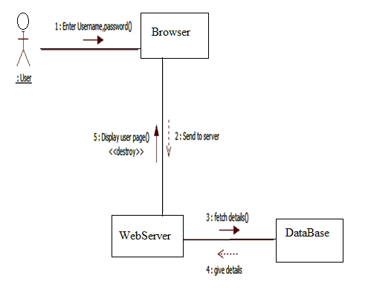

Registration

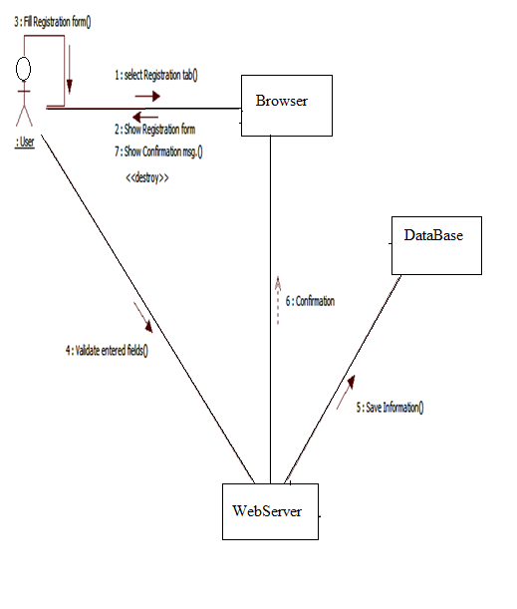

**4.11 Component Diagram**

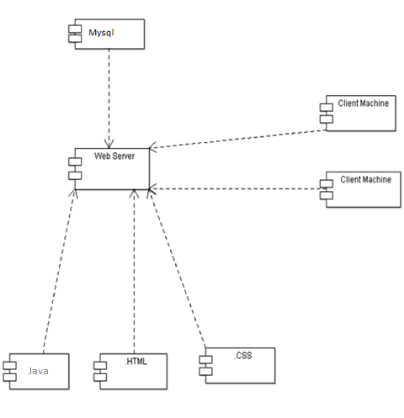

**4.12 Deployment Diagram**

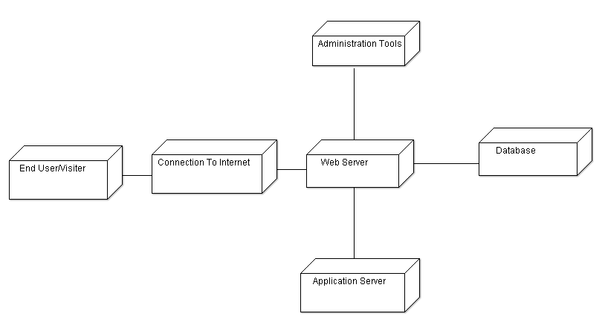

**Object Diagram**

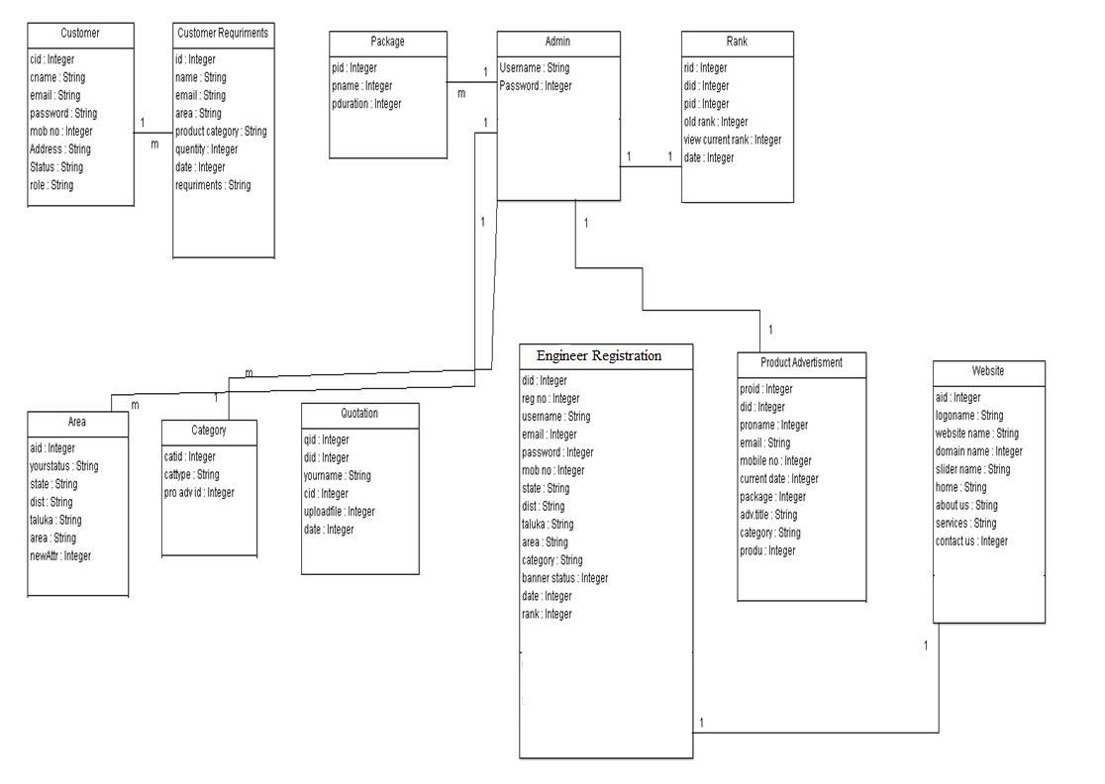

**Class Diagram**

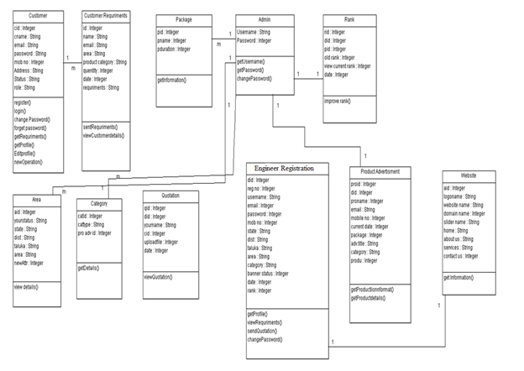

* 1. **Database Design**

**Table Design**

1. Admin

|  |  |  |  |  |
| --- | --- | --- | --- | --- |
| **Column Name** | **Data Type** | **Null able** | **Default** | **Constraints** |
| UserName | VARCHAR(20) | No | - | PK |
| Passsword | VARCHAR(20) | No | - | - |

1. Customer

|  |  |  |  |  |
| --- | --- | --- | --- | --- |
| **Column Name** | **Data Type** | **Null able** | **Default** | **Constraints** |
| Id | Number(10) | No | - | - |
| Cust_email | VARCHAR(20) | No | - | PK |
| Password | VARCHAR(20) | No | - | - |
| Name | VARCHAR(20) | No | - | - |
| Address | VARCHAR(100) | No | - | - |
| Mobile number | VARCHAR(13) | No |  |  |
| Status | VARCHAR(10) | No | - | - |
| OPT | Number (10) |  | - | - |

1. Vendor

|  |  |  |  |  |
| --- | --- | --- | --- | --- |
| **Column Name** | **Data Type** | **Null able** | **Default** | **Constraints** |
| Id | Number(10) | No | - | - |
| Vendor_email | VARCHAR(20) | No | - | PK |
| Password | VARCHAR(20) | No | - | - |
| Name | VARCHAR(20) | No | - | - |
| Shop Name | VARCHAR(20) | No | - | - |
| Address | VARCHAR(100) | No | - | - |
| Mobile number | VARCHAR(13) | No | - | - |
| Area | VARCHAR(20) | No | - | - |
| Category | VARCHAR(20) | No | - | - |
| Rank | Number | No | - | - |
| Banner | VARCHAR(20) | No | - | - |
| Status | VARCHAR(10) | No | - | - |
| Date | Date | No | - | - |
| Package | VARCHAR(20) | No | - | - |
| OPT | Number (10) |  | - |  |

1. Engineer

|  |  |  |  |  |
| --- | --- | --- | --- | --- |
| **Column Name** | **Data Type** | **Null able** | **Default** | **Constraints** |
| Id | Number(10) | No | - | - |
| Engineer_email | VARCHAR(20) | No | - | PK |
| Password | VARCHAR(20) | No | - | - |
| Name | VARCHAR(20) | No | - | - |
| Shop Name | VARCHAR(20) | No | - | - |
| Address | VARCHAR(100) | No | - | - |
| Mobile number | VARCHAR(13) | No | - | - |
| Area | VARCHAR(20) | No | - | - |
| Category | VARCHAR(20) | No | - | - |
| Rank | Number | No | - | - |
| Banner | VARCHAR(20) | No | - | - |
| Status | VARCHAR(10) | No | - | - |
| Date | Date | No | - | - |
| Package | VARCHAR(20) | No | - | - |
| OPT | Number (10) |  | - |  |

1. Rank

|  |  |  |  |  |
| --- | --- | --- | --- | --- |
| **Column Name** | **Data Type** | **Null able** | **Default** | **Constraints** |
| Id | Number (10) | No | - | PK |
| Engg_email | VARCHAR(20) | No | - | FK |
| Old rank | VARCHAR(20) | No | - |  |
| New Rank | Number (10) | No | - |  |
| Package | Number (10) | No | - | FK |
| Date | Date | No | - |  |

1. Website

|  |  |  |  |  |
| --- | --- | --- | --- | --- |
| **Column Name** | **Data Type** | **Null able** | **Default** | **Constraints** |
| Id | Number (10) | No | - | PK |
| Engg_email | VARCHAR(20) | No | - | FK |
| Password | VARCHAR(20) | No | - | - |
| Domain Name | VARCHAR(20) | No | - | - |
| Package | VARCHAR(20) | No | - | FK |
| Name | VARCHAR(20) | No | - |  |
| Home | VARCHAR(500) | No | - | - |
| About | VARCHAR(500) | No | - |  |
| Services | VARCHAR(500) | No | - |  |
| Contact | VARCHAR(500) | No | - |  |
| Sidebar | VARCHAR(500) | No | - |  |
| Slider | VARCHAR(10) | No | - |  |
| Date | Date | No | - |  |

1. Add Area

|  |  |  |  |  |
| --- | --- | --- | --- | --- |
| **Column Name** | **Data Type** | **Null able** | **Default** | **Constraints** |
| Id | Number (20) | No | - | PK |
| Area | VARCHAR(20) | No | - | - |

1. Add Category

|  |  |  |  |  |
| --- | --- | --- | --- | --- |
| **Column Name** | **Data Type** | **Null able** | **Default** | **Constraints** |
| Id | Number (20) | No | - | PK |
| Main_cat | VARCHAR(20) | No | - |  |
| Category | VARCHAR(20) | No | - | - |

1. Package

|  |  |  |  |  |
| --- | --- | --- | --- | --- |
| **Column Name** | **Data Type** | **Null able** | **Default** | **Constraints** |
| Id | Number (20) | No | - | PK |
| Pk_name | VARCHAR(20) | No | - | - |
| Cost | Number (10) | No | - |  |
| Duration | VARCHAR(20) | No | - |  |

1. Add banner

|  |  |  |  |  |
| --- | --- | --- | --- | --- |
| **Column Name** | **Data Type** | **Null able** | **Default** | **Constraints** |
| Id | Number (20) | No | - | PK |
| Name | VARCHAR(20) | No | - |  |
| Email id | VARCHAR(20) | No | - |  |
| Package | VARCHAR(20) | No | - | FK |
| Mobile no | VARCHAR(13) | No | - |  |
| Path | VARCHAR(20) | No | - |  |
| Date | Date | No | - |  |

1. Service Advertisement

|  |  |  |  |  |
| --- | --- | --- | --- | --- |
| **Column Name** | **Data Type** | **Null able** | **Default** | **Constraints** |
| Id | Number (20) | No | - | PK |
| Name | VARCHAR(20) | No | - |  |
| Email id | VARCHAR(20) | No | - |  |
| Title | VARCHAR(20) | No | - |  |
| Mobile no | VARCHAR(13) | No | - |  |
| Package | VARCHAR(20) | No | - | FK |
| Category | VARCHAR(200) | No | - |  |
| Info | VARCHAR(500) | No | - |  |
| Date | Date | No | - |  |
| Image | VARCHAR(20) | No | - |  |

1. Send Quotation

|  |  |  |  |  |
| --- | --- | --- | --- | --- |
| **Column Name** | **Data Type** | **Null able** | **Default** | **Constraints** |
| Id | Number (20) | No | - | PK |
| Cust_email | VARCHAR(20) | No | - | FK |
| Engg_email | VARCHAR(20) | No | - | FK |
| Quotation_file | VARCHAR(20) | No | - |  |
| Date | Date | No | - |  |
| Status | VARCHAR(10) | No | - |  |

1. Send requirement

|  |  |  |  |  |
| --- | --- | --- | --- | --- |
| **Column Name** | **Data Type** | **Null able** | **Default** | **Constraints** |
| Id | Number (20) | No | - | PK |
| Cust_email | VARCHAR(20) | No | - | FK |
| Name | VARCHAR(20) | No | - |  |
| Area | VARCHAR(20) | No | - |  |
| Category | Date | No | - |  |
| Address | VARCHAR(100) | No | - |  |
| Requirement | VARCHAR(200) | No | - |  |
| Quantity | Number (10) | No | - |  |
| Date | Date | No | - |  |
| Status | VARCHAR(10) | No | - |  |

1. Contact us

|  |  |  |  |  |
| --- | --- | --- | --- | --- |
| **Column Name** | **Data Type** | **Null able** | **Default** | **Constraints** |
| Id | Number (20) | No | - | PK |
| Name | VARCHAR(20) | No | - |  |
| Email id | VARCHAR(20) | No | - | - |
| Subject | VARCHAR(20) | No | - |  |
| Message | VARCHAR(200) | No | - |  |

**Data Dictionary**

**DATA DICTIONARY**

|  |  |  |  |  |  |
| --- | --- | --- | --- | --- | --- |
| **Sr.No** | **Column Name** | **Data Type** | **Null able** | **Default** | **Constraints** |
| 1 | UserName | VARCHAR(20) | No | - | PK |
| 2 | Passsword | VARCHAR(20) | No | - | - |
| 3 | Id | Number(10) | No | - | - |
| 4 | Cust_email | VARCHAR(20) | No | - | PK |
| 5 | Password | VARCHAR(20) | No | - | - |
| 6 | Name | VARCHAR(20) | No | - | - |
| 7 | Address | VARCHAR(100) | No | - | - |
| 8 | Mobile number | VARCHAR(13) | No |  |  |
| 9 | Status | VARCHAR(10) | No | - | - |
| 10 | OPT | Number (10) |  | - | - |
| 11 | Id | Number(10) | No | - | - |
| 12 | Engg_email | VARCHAR(20) | No | - | PK |
| 13 | Password | VARCHAR(20) | No | - | - |
| 14 | Name | VARCHAR(20) | No | - | - |
| 15 | Shop Name | VARCHAR(20) | No | - | - |
| 16 | Address | VARCHAR(100) | No | - | - |
| 17 | Mobile number | VARCHAR(13) | No | - | - |
| 18 | Area | VARCHAR(20) | No | - | - |
| 19 | Category | VARCHAR(20) | No | - | - |
| 20 | Rank | Number | No | - | - |
| 21 | Banner | VARCHAR(20) | No | - | - |
| 22 | Status | VARCHAR(10) | No | - | - |
| 23 | Date | Date | No | - | - |
| 24 | Package | VARCHAR(20) | No | - | - |
| 25 | OPT | Number (10) |  | - |  |
| 26 | Id | Number (10) | No | - | PK |
| 27 | Engg_email | VARCHAR(20) | No | - | FK |
| 28 | Old rank | VARCHAR(20) | No | - |  |
| 29 | New Rank | Number (10) | No | - |  |
| 30 | Package | Number (10) | No | - | FK |
| 31 | Date | Date | No | - |  |
| 32 | Id | Number (10) | No | - | PK |
| 33 | Engg_email | VARCHAR(20) | No | - | FK |
| 34 | Old rank | VARCHAR(20) | No | - |  |
| 35 | New Rank | Number (10) | No | - |  |
| 36 | Package | Number (10) | No | - | FK |
| 37 | Date | Date | No | - |  |
| 38 | Id | Number (10) | No | - | PK |
| 39 | Engg_email | VARCHAR(20) | No | - | FK |
| 40 | Password | VARCHAR(20) | No | - | - |
| 41 | Domain Name | VARCHAR(20) | No | - | - |
| 42 | Package | VARCHAR(20) | No | - | FK |
| 43 | Name | VARCHAR(20) | No | - |  |
| 44 | Home | VARCHAR(500) | No | - | - |
| 45 | About | VARCHAR(500) | No | - |  |
| 46 | Services | VARCHAR(500) | No | - |  |
| 47 | Contact | VARCHAR(500) | No | - |  |
| 48 | Sidebar | VARCHAR(500) | No | - |  |
| 49 | Slider | VARCHAR(10) | No | - |  |
| 50 | Date | Date | No | - |  |
| 51 | Id | Number (20) | No | - | PK |
| 52 | Area | VARCHAR(20) | No | - | - |
| 53 | Id | Number (20) | No | - | PK |
| 54 | Main_cat | VARCHAR(20) | No | - |  |
| 55 | Category | VARCHAR(20) | No | - | - |
| 56 | Id | Number (20) | No | - | PK |
| 57 | Pk_name | VARCHAR(20) | No | - | - |
| 58 | Cost | Number (10) | No | - |  |
| 59 | Duration | VARCHAR(20) | No | - |  |
| 60 | Id | Number (20) | No | - | PK |
| 61 | Name | VARCHAR(20) | No | - |  |
| 62 | Email id | VARCHAR(20) | No | - |  |
| 63 | Package | VARCHAR(20) | No | - | FK |
| 64 | Mobile no | VARCHAR(13) | No | - |  |
| 65 | Path | VARCHAR(20) | No | - |  |
| 66 | Date | Date | No | - |  |
| 67 | Id | Number (20) | No | - | PK |
| 68 | Name | VARCHAR(20) | No | - |  |
| 69 | Email id | VARCHAR(20) | No | - |  |
| 70 | Package | VARCHAR(20) | No | - | FK |
| 71 | Mobile no | VARCHAR(13) | No | - |  |
| 72 | Path | VARCHAR(20) | No | - |  |
| 73 | Date | Date | No | - |  |
| 74 | Id | Number (20) | No | - | PK |
| 75 | Name | VARCHAR(20) | No | - |  |
| 76 | Email id | VARCHAR(20) | No | - |  |
| 77 | Title | VARCHAR(20) | No | - |  |
| 78 | Mobile no | VARCHAR(13) | No | - |  |
| 79 | Package | VARCHAR(20) | No | - | FK |
| 80 | Category | VARCHAR(200) | No | - |  |
| 81 | Info | VARCHAR(500) | No | - |  |
| 82 | Date | Date | No | - |  |
| 83 | Image | VARCHAR(20) | No | - |  |
| 84 | Id | Number (20) | No | - | PK |
| 85 | Cust_email | VARCHAR(20) | No | - | FK |
| 86 | Engg_email | VARCHAR(20) | No | - | FK |
| 87 | Quotation_file | VARCHAR(20) | No | - |  |
| 88 | Date | Date | No | - |  |
| 89 | Status | VARCHAR(10) | No | - |  |
| 90 | Id | Number (20) | No | - | PK |
| 91 | Cust_email | VARCHAR(20) | No | - | FK |
| 92 | Name | VARCHAR(20) | No | - |  |
| 93 | Area | VARCHAR(20) | No | - |  |
| 94 | Category | Date | No | - |  |
| 95 | Address | VARCHAR(100) | No | - |  |
| 96 | Requirement | VARCHAR(200) | No | - |  |
| 97 | Quantity | Number (10) | No | - |  |
| 98 | Date | Date | No | - |  |
| 99 | Status | VARCHAR(10) | No | - |  |
| 100 | Id | Number (20) | No | - | PK |
| 101 | Name | VARCHAR(20) | No | - |  |
| 102 | Email id | VARCHAR(20) | No | - | - |
| 103 | Subject | VARCHAR(20) | No | - |  |
| 104 | Message | VARCHAR(200) | No | - |  |

**5. Testing**

**5.1.1 Strategies used for Testing**

**1. Unit Testing**

Unit testing concentrates verification on the smallest element of the program – the module. Using the detailed design description important control paths are tested to establish errors within the bounds of the module.

In this system each sub module is tested individually as per the unit testing such as campaign, lead, contact etc are tested individually. Their input field validations are tested.

**2. Integration testing**

Once all the individual units have been tested there is a need to test how they were put together to ensure no data is lost across interface, one module does not have an adverse impact on another and a function is not performed correctly.

After unit testing each and every sub module is tested with integrating each other.

**System testing for the current system:**

In this level of testing we are testing the system as a whole after integrating all the main modules of the project. We are testing whether system is giving correct output or not. All the modules were integrated and the flow of information among different modules was checked. It was also checked that whether the flow of data is as per the requirements or not. It was also checked that whether any particular module is non-functioning or not i.e. once the integration is over each and every module is functioning in its entirety or not.

In this level of testing we tested the following: -

* Whether all the forms are properly working or not.
* Whether all the forms are properly linked or not.
* Whether all the images are properly displayed or not.
* Whether data retrieval is proper or not.

Specific knowledge of the application's code/internal structure and programming knowledge in general is not required. The tester is aware of *what* the software is supposed to do but is not aware of *how* it does it. For instance, the tester is aware that a particular input returns a certain, invariable output but is not aware of *how* the software produces the output in the first place.

**Test** **Cases**

Test cases are built around specifications and requirements, i.e., what the application is supposed to do. Test cases are generally derived from external descriptions of the software, including specifications, requirements and design parameters. Although the tests used are primarily *functional* in nature, *non-functional* tests may also be used. The test designer selects both valid and invalid inputs and determines the correct output without any knowledge of the test object's internal structure.

Te**st Design Technique**s

Typical black-box test design techniques include:

* Decision table testing
* All-pairs testing
* State transition Analysis
* Equivalence partitioning
* Boundary value analysis
* Cause–effect graph
* Error guessing

**Advantages**

* Efficient when used on large systems.
* Since the tester and developer are independent of each other, testing is balanced and unprejudiced.
* Tester can be non-technical.
* There is no need for the tester to have detailed functional knowledge of system.
* Tests will be done from an end user's point of view, because the end user should accept the system. (This testing technique is sometimes also called Acceptance testing.)
* Testing helps to identify vagueness and contradictions in functional specifications.
* Test cases can be designed as soon as the functional specifications are complete.

**Disadvantages**

* Test cases are challenging to design without having clear functional specifications.
* It is difficult to identify tricky inputs if the test cases are not developed based on specifications.
* It is difficult to identify all possible inputs in limited testing time. As a result, writing test cases may be slow and difficult.
* There are chances of having unidentified paths during the testing process.
* There is a high probability of repeating tests already performed by the programmer.

**1] Test case For Admin Login Page:**

Project Name: Dream Home

Prepared Date:- 29-03-2018 Prepared By:-Mr

Module Name: Login. Reviewed Date:-15-03-2018

Project Code: - DH. Reviewed By:-Mr

Total no of test Cases:-04

Total no of test Cases Passed:-04

Total no of test Cases failed:-00

Total no of test Cases executed:-04

Total no of test Cases pending:-00

|  |  |  |  |  |  |
| --- | --- | --- | --- | --- | --- |
| **Test Case ID** | **Test Case Procedure** | **Input**  **Data** | **Expected**  **Output** | **Actual Output** | **Test**  **Status** |
| DST-LG-01 | Checking the functionality of Admin LOGIN Button | 1.Enter valid Usernames in textbox  2. Enter valid Password in textbox  3. Click on Admin LOGIN Button | Admin Welcome page should be displayed | Admin Welcome page displayed | Pass |
| DST -LG-02 | Checking the functionality of Admin LOGIN Button | 1.Enter invalid User Name in text box  2. Enter valid Password in password textbox  3. Click on Admin LOGIN Button | Admin Welcome page should not be displayed | Admin Welcome page is not displayed | Pass |
| DST -LG-03 | Checking the functionality of Admin LOGIN Button | 1.Enter valid User name in User name textbox  2. Enter invalid Password in password textbox  3. Click on Admin LOGIN Button | Admin Welcome page should not be displayed | Admin Welcome page is not displayed | Pass |
| DST -LG-04 | Checking the functionality of Admin LOGIN Button | 1.Enter invalid User name in User name textbox  2. Enter invalid Password in password textbox  3. Click on Admin LOGIN Button | Admin Welcome page should not be displayed | Admin Welcome page is not displayed | Pass |

**2] Test case For Add Engg Page:**

Project Name: Dream Home.

Prepared Date:-29-03-2018. Prepared By:-Mr

Module Name: Add Vendor. Reviewed Date:- 15-03-2018

Project Code: - DH Reviewed By:-Mr

Total no of test Cases:-04

Total no of test Cases Passed:-04

Total no of test Cases failed:-00

Total no of test Cases executed:-04

Total no of test Cases pending:-00

|  |  |  |  |  |  |
| --- | --- | --- | --- | --- | --- |
| **Test Case ID** | **Test Case Procedure** | **Input**  **Data** | **Expected**  **Output** | **Actual Output** | **Test**  **Status** |
| DST-AD-01 | Checking the functionality of Add Engg Button | 1.Enter valid First name, last name and the firm name in textbox  2. Enter valid Mobile no and email id.  3.Select valid State, District, Taluka, and village  3. Click on Add Button | Engg added Successfully should be displayed | Engg  added Successfully displayed | Pass |

|  |  |  |  |  |  |
| --- | --- | --- | --- | --- | --- |
| DST-AD-01 | Checking the functionality of Add Vendor Button | 1.Enter valid First name, last name and the firm name in textbox  2. Enter valid Mobile no and email id.  3.Select valid State, District, Taluka, and village  3. Click on Add Button | Vendor added Successfully should be displayed | Vendor added Successfully displayed | Pass |
| DST -AD-02 | Checking the functionality of Add Vendor Button | 1.Enter invalid First name, last name and the firm name in textbox  2. Enter valid Mobile no and email id.  3.Select valid State, District, Taluka, and village  3. Click on Add Button | Vendor added Successfully should not be displayed | Vendor not added Successfully displayed | Pass |
| DST -AD-03 | Checking the functionality of Add Vendor Button | 1.Enter valid First name, last name and the firm name in textbox  2. Enter invalid Mobile no and email id.  3.Select valid State, District, Taluka, and village  3. Click on Add Button | Vendor added Successfully should not be displayed | Vendor not added Successfully displayed | Pass |
| DST -AD-04 | Checking the functionality of Add  Vendor Button | 1.Enter valid First name, last name and the firm name in textbox  2. Enter valid Mobile no and email id.  3.Select invalid State, District, Taluka, and village  3. Click on Add Button | Vendor added Successfully should not be displayed | Vendor not added Successfully displayed | Pass |

**8. PROPOSED ENHANCEMENT**

The proposed enhancements of this system are as follows:

1. This system will convert into Android version and make available it for android devices.

2. Integration with external outlook plug-in.

3. Integration with external plug-ins to improve the performance and functionality of system.

4. Dynamic and easy graphical report generation.

5. Integration with office plug-in.

**8.1. User Manual**

This user manual is meant to be used by the all user using the system, with prior training session from the Development unit, plus he/she has to be skilful enough in operating the intended system. This manual is used for the benefit of the intended user to make it more understandable along with functioning of the system, the processes and the precautions that must be followed during working with the system. It also tells the user how to use various functionality of the system as various college are being provided according to the type of user, whenever user logs into the system.

This System is very easy to operate to those who have the Fundamental knowledge of computer operations & little bit of the help of this user manual. The appropriate error message & supporting help makes this online web application easy to handle.

Now, in order to get a better understanding of the system various user interfaces along-with directions are also provided in the user-interface designs.

**How to Use the System:**

There are three type of user:-

1. Admin
2. Engineer
3. Customer

**User Manual for Admin**

* **Login**

1. Enter username and password
2. Admin will be redirected to admin’s Dashboard page. The admin’ll see various links for different operations.

**Following operations can be performed by admin:**

* View List of Customer
* Admin can see the total list of the registered customer.
* Vendor Registration
* Here admin can register the Engineer.
* Engineer will get the User name and the auto generated password through mail
* Engineer List
* Here admin can see the list of the Registered Engineer.
* Improve Rank
* Here admin can improve the Engineer Banner’s Rank on the home page..
* Improved Rank
* View all the list of improved rank.
* Create Engineer Website
* Admin can create the dynamic Website under domain of the www.dreamhome.com
* Created Engineer Website
* View the entire dynamically created website list.
* Add Banner
* Here admin can add the banner on home page on search requirement.
* Add Slider
* To add the slider images on Home page.
* Add Product Advertisement
* Admin can add the Product advertisement images it will reflect websites advertisement Menu.
* Add Area
* Here admin can add the new area.
* Add Category
* Admin can add the new category.
* Created Package
* Here admin can create the package.
* Contact Us Message
* Here admin can manage the contact us data.
* Change Password
* Admin can change the password.

**User Manual for Engineer**

* My Profile
* Engineer can his/her own profile and edit it.
* View Sent Quotation
* Here Engineer can see the total list of sent quotations.
* View Requirement
* Engineer can view all the requirement area wise.
* Change Password
* Engineer can change the password.

**User Manual for Customer**

* My Profile
* Customer can his/her own profile and edit it.
* View Sent Requirement
* Customer can see the total list of sent requirements, likewise Text, Photos, Blueprint.
* Send Quotation
* Here customer can send the requirement to vendor area wise.
* View Quotations
* Here customer can see the quotations sent by the vendor in respective area.
* Change Password
* Here customer can change the password.

**User Manual for Website**

* Home
* This is the main home page of the website.
* On this home page user can see the banner images of the dealer and the slider images.
* Advertisement
* Through this menu tab User can see the product advertisement category wise and the area wise.
* Services
* This is the services page of the website.
* Area Cover
* Here admin can see the total area cover by the website.
* Contact
* This is the contact us page of the website.
* Gallery Page for maintain previous and new project.
  1. **Conclusion**

**Conclusion-**

From the consideration of all the above points we conclude that this project is developed to facilitate the Data regarding the entire user like admin can easily manage all engineer and the customer data etc. administrator can add easily engineer and customer and assigns roles to them. Admin can manage Advertisement, Engineer List, Customer List, Dynamic Website Creation, Requirement settings and all. Here Engineer can send the Quotation to the customer before that customer send his/her requirement to the engineer in respective area only. Finally we conclude that customer get multiple quotation in respective area at one place only and get home which he design in his/her dream. So indirectly we save the time and money.

* 1. **Bibliography**
* **Ivan Bayross, “HTML, DHTML, Java Script, Perl & CGI”, BPB Publications**
* **Systems Analysis, Design and Introduction to Software Engineering By S. Parthasarathy & B. W. Khalkar.**
* **Java Complete Reference**

**WEB REFERENCES-**

[**http://www.w3schools.com**](http://www.w3schools.com)

[**http://www.Wikipedia.org**](http://www.Wikipedia.org)

[**http://www.jqueryui.com**](http://www.jqueryui.com)

[**http://www.sugarcrm.com**](http://www.sugarcrm.com)

[**http://www.stackoverflow.com**](http://www.stackoverflow.com)